

Inception Report

**Continuous Simulation of Urban Sanitary Sewer Network in Cold Climate: Forecast and Automatic Calibration**

Pedro Paulo Almeida Silva  
EuroAquae+ Student

April 2019

1. Academic Supervisor: apl. Prof. Dr.-Ing. habil. Frank Molkenthin
2. Institutional Supervisor: Dr. Markus Sunela

**TABLE OF CONTENTS**

INCEPTION REPORT DESCRIPTION

1. INTRODUCTION 3

2. MOTIVATION 3

3. METHODOLOGY 4

3.1. Offline model: 4

3.2. Online Model: Continuous simulation 5

3.3. Time Schedule 7

4. HYDROLOGICAL MODEL 7

4.1. Methods to Quantify Rainfall Dependent Infiltration and Inflow 8

4.2. How to separate RDII Stages from Hydrographs – Wet weather flow (WWF) 11

5. HYDRAULIC MODEL 12

5.1. Demand estimation 12

6. DATA AND CASE STUDIES 12

6.1. Data 12

6.2. Jokela Town 14

6.3. Turku City 17

7. Open Questions 17

8. Bibliography 18

**INCEPTION REPORT DESCRIPTION**

The purpose of this report is to present the topic of the proposed thesis. This paper has initial information on problem description, proposed methodology, initial literature review, research and work done so far. Sections were divided as an attempt to illustrate the different components necessary to complete the project. First sections present a description of the topic and motivations. Remaining sections present a short description of the work planned and/or expected results. Content in each section varies since information regarding the understanding of the project was initially prioritized. For the last section, open questions that should guide the next efforts of the research were presented.

# INTRODUCTION

Modelling sanitary sewer network flows allow cities to understand and solve issues that impact its society, environment and economy. To model sanitary sewer network flows, it is first necessary to identify the behavior of the system. Flows in the network usually have two different behaviors that are classified as: 1. dry-weather flow (DWF); 2. wet-weather flow (WWF) [1]. To apply a continuous simulation and successfully forecast the flows in the sanitary sewer system, the model should be able to account for both DWF and WWF.

Typically, DWF pattern can be estimated by analyzing historical data from flow measurements available along the network or at the downstream end during dry periods [2]. Intuitively, usually more water is discharged into the sewer in day time than during the night. More complexity is added when trying to estimate WWF in the sanitary sewer network. Flow increases in the network due to inflow and infiltration often trigged by rainfall or snowmelt. This incremental quantity of flow which finds its way into the sanitary sewer network during a rainfall event is known by Rainfall Dependent Inflow and Infiltration (RDII).

The challenge on RDII estimations lies upon the different ways stormwater enters a sanitary or combined sewer [3]. Stormwater can inflow to the sanitary or combined sewer network directly through foundation and roof drains connections, leaky manhole covers, or stormwater drains. Infiltration occurs due to defects in the network components such as: damaged pipes, joints, manholes, etc. [4]

Quantity of inflow and infiltration (I&I) increases proportionally with intensity of the rainfall and snowmelt. Urban areas located in cold climate can have a significant inflow due to snowmelt and was, therefore, considered during this study. For that, the incremental flow caused by snowmelt will be referred here as Snowmelt Dependent Inflow and Infiltration (SDII). Event-based Inflow and Infiltration (EBII) will be used as a general term for both snowmelt and rainfall inflow and infiltration.

# MOTIVATION

Event-base inflow and infiltration (EBII) causes increase of the quantity of flow into sanitary sewer systems. This increase may cause sanitary sewer overflow (SSO) due to exceedance of the system capacity [4]. In some cities, sanitary sewer is combined with stormwater sewer network. The capacity of this coupled systems may also be exceeded during an event causing combined sewer overflow (CSO) [1]. When the capacity is exceeded, untreated water rejected by the wastewater treatment plants (WWTPs) is released into surface waters [5] such rivers and streams. Upstream capacity-related issues may cause wastewater to find its way into basements or streets [6]. Untreated water released on the surface water bodies or urban area increases the risk of human contamination by infectious diseases.

Although these are well known problems, they are still present in urban centers around the globe. Frequency of CSOs are seasonal dependent. The current prediction of more frequent intensive rainfall events also increases the frequency of CSO [5] and enlarge the damage caused by these overflows. Moreover, wastewater overflows can cause conflicts in the society when streams or rivers are used both as an option to dispose wastewater and recreational area [7]. To give cities, municipalities and water utilities the ability to predict SSOs and CSOs is one of the motivations of this study. However, other benefits are also aimed. A continuous simulation considering urban hydrology and hydraulics can also be used to improve the service and reduce operational costs for water utilities.

EBII can increase the inflow of wastewater to WWTPs for weeks due to possible long response times [3]. Obviously, the operational cost of the plant will increase since more wastewater needs to be treated. A continuous simulation might be able to identify increases over time on the flow pattern in specific pipes or sub-divisions of the network. This would be an indicator for to water utility to carry further inspections and evaluate whether the infrastructure is damaged allowing infiltration. Furthermore, a digital model of the network gives to the water utilities the ability to analyze the impacts on the whole network caused by changes in the network such as: decommissioning of a water tower, changing pumping schedule, or analyzing impacts of a future neighborhood.

# METHODOLOGY

To tackle the issues presented in the previous section, this study will investigate the main aspects behind the development of a model with the aim to approximate the behavior of the sanitary sewer network flows continuously. The model should be able to cope with existing monitoring infrastructure (SCADA) and use this information and weather forecast data as input to predict the future status of the network. It is important to consider the purpose of the model since the beginning once it influences the decisions of methods to be used. Thus, the development of the model will, since the beginning, acknowledge the following:

* fetching of real-time monitoring data;
* automatic calibration & validation;
* State of network in different nodes;
* Transfer times among pumping stations;
* 24h forecast: possible overflows, capacities, etc.

There is current one town to be used as study site. The town of Jokela, in Tuusula municipality, is in the southern region of Finland. A larger urban area of Turku city, in southwest coast of Finland, might also be used as case study. More about Jokela area is discussed on section 7. The hydraulic model for Jokela region was already built and provided by Tuusula Water Works for this study.

Methodology proposed to build the model is to first create an offline model with historical events and an online model as a continuous simulation.

## Offline model:

First step will be the creation of hydrological model and coupling to hydraulic model using Storm Water Management Model (SWMM) developed by the U.S. Environment Protection Agency (EPA). The model will be built, calibrated and validated using historical data. The goal is to identify the best set of parameters and how to handle challenging parts such as: initial soil moisture content, soil frost, percentage of rainfall lost to stormwater sewer network. Figure 1 shows a very simplified flowchart of the hydrological model development steps.

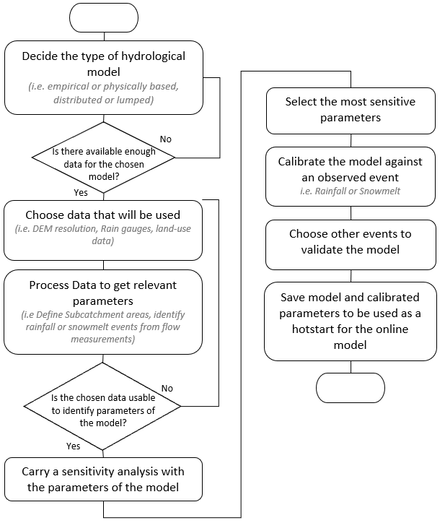

Figure 1: Hydrological Model Development Flowchart

## Online Model: Continuous simulation

This section presents questions related to the continuous simulation process. The answers express initial ideas to explain how the continuous simulation will work and what are the main concerns.

* **How long will the simulations run?** This depends on many factors such as the type of hydrological, hydraulic model, calibration process, routine, hardware used to process the information.
* **How often will the simulation run?** Routine of simulation is constraint by data acquisition routine. The routine of simulation can also vary during a storm event applying a shorter time of simulation. As an example, imagine if all necessary data to run a simulation is available every 15min and the model takes 30min to run a complete simulation, the iterations necessary for the optimization of parameters during the calibration process can be reduced as an attempt to decrease the time of simulation down to 15min. This could allow a better decision-making process during intense rainfall events, even if some accuracy is compromised.
* **What information is relevant before, during, and after a rainfall or snowmelt event?**  
  ***Before the rainfall and/or snowmelt****:* When and where peak flows will happen in the sanitary sewer system. Where and when can CSOs or SSOs can happen. What would be the transfer times between points of the network? ***During rainfall and/or snowmelt:*** Status of the system with focus in short-time forecast (+1-2h): Where are the peak flows, CSOs, SSOs, happening and how will then be within 1-2h. Are all the measurement instruments safe and providing good enough data? Maybe a quick check of the input data will be necessary to identify whether the instrument is broken or not. If we cannot rely on the real-time data, what would be the strategy? Maybe use the last reliable data collected to forecast the behavior of the system. ***After rainfall and/or snowmelt:*** Maybe the peak flows will still happen. How long will the flows in the system still be considered RDII and higher than average peak flows of DWF?
* **Which parameters will be calibrated?** According do Choi and Ball (2002) [8] there are two types of parameters related to quantity part of runoff block in SWMM: 1. Measured Parameters; 2. Inferred Parameters. The first are parameters directly measured such length of channels/pipes, catchment land-use, or recorded rainfall depth. The second, parameters not directly measured, and coefficients used by empirical models that approximate complex physical processes. More about this is discussed in section 4. Inferred parameters approximate characteristics of the system (i.e. imperviousness) and processes (i.e. flow coefficients such as hydraulic conductivity or manning’s). Inferred parameters are the least known values since no measurements were carried. Therefore, they are the first candidates to be chosen when calibrating since the uncertainties tend to be higher than the measured parameters. A sensitivity analysis will be done during the offline modelling part to identify which of the inferred parameters have greater impact to the results. The inferred parameters with greater impacts will be then chosen for calibration.
* **Why not all parameters will be calibrated?** The number of parameters necessary to run SWMM and the range of possible values for each parameter can be a very large number. This increases the search space for the calibration algorithm where many iterations will be required to identify optimal set of parameters. This can rapidly increase the time of simulation limiting the model’s forecast capability.
* **How will the Automatic Calibration Process** **work?** The automatic calibration will have a routine according to the necessity of the models. A calibration run might happen in scale of hours, days, weeks, months, etc. A new set of parameters will then be proposed and an evaluation to compare whether the new set of parameters is better than the previous one. The frequency of calibration and the possible values of the parameters must be further investigated since less frequent events might have very distinct behavior than more frequent events. It is also possible to define different set of parameters for different seasons and event’s magnitude. An approximated system diagram is shown in Figure 2.

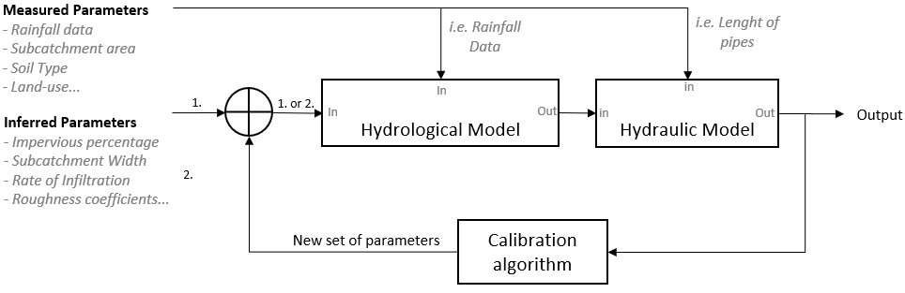

Figure 2: System Diagram

**Automatic Calibration: DDS**

DDS is a stochastic single-solution based heuristic global search algorithm that was created for the automatic calibration process of watershed simulation models. It was developed to find good global solution for a set of parameters faster than previously available search algorithms [9].

DDS mimics the process of manual calibration where the workflow can be defined as (1) change parameters of the model (2) run the model simulation (3) measure error of simulated vs observed (4) repeat previous steps and choose the most fit set of parameters. For hydrologic models with multiple subcatchments and parameters, the number of possible combinations of parameters are of several orders of magnitude. This complexity motivates the adoption of optimization algorithms for automatic calibration.

For a given hydrologic model with only one catchment and three different parameters: area, slope, and roughness. Assuming that area is constant but the other two can assume each five other possible values. The possible combination of parameters to represent the catchment would be 165. Now let’s assume the catchments is divided in two subcatchments. In this case, the possible number of combinations would raise to 74613.

The name *Dynamically Dimensioned* is given due to the ability of the algorithm to scale the search based on user-specified maximum number of iterations. Global search approach is used for the first iterations. DDS switches to a local search approach by selecting and reducing the search space when the number of iterations nears the maximum allowed. The algorithm reduces the search space by strategic reduction of the number of parameters to be calibrated when it approximates to the end of the search. It also respects the constraints of each parameter given by the user. Therefore, it does not choose values for a parameter out of the specified range.

Other relevant aspects of Automatic Calibration and DDS for SWMM:

* Automatic Calibration avoids modelers bias, accelerates the process of calibration, and handles multiple objectives such as peak flows, hydrograph shape, and total volume. [10]
* DDS was created for computationally expensive calibrations [11]. Therefore, it is suitable for SWMM where a possible large number of parameters should be simultaneously optimized.
* DDS converges rapidly finding a good solution for a set of parameters and successfully avoid poor local solutions [9].
* For distributed model such as used in SWMM, comparisons available in the literature have proven that DDS is one of the fastest to converge and the best finding good solutions. In other words, DDS does outperform other algorithms for complex models [9][12][11].
* SSOAP toolbox allows the users to visually adjust RTK parameters comparing the flow measured values and the RTK hydrograph through an iterative process [1]. Using such tool make the process easier for modelers. However manual calibration can be time consuming and limit the frequency of calibrations for continuous simulations. Optimization algorithm is applied as an attempt to mimic this iterative process done manually by modelers.

Ideas for the optimization algorithm for calibration process:

* Multi-objective function: Evaluate the peak of hydrographs but also the volumes. i.e. From Jan to April emphasis on volume, so higher penalties applied for errors in the volume. The opposite applies for periods from April to December. Higher penalties can also be applied for R and T values that fails to reach the peak and time to peak of high intensity storms (i.e >5-years return period storm). This tries to mimic modeler’s judgement when visually adjusting RTK values for a best fit.

## Time Schedule

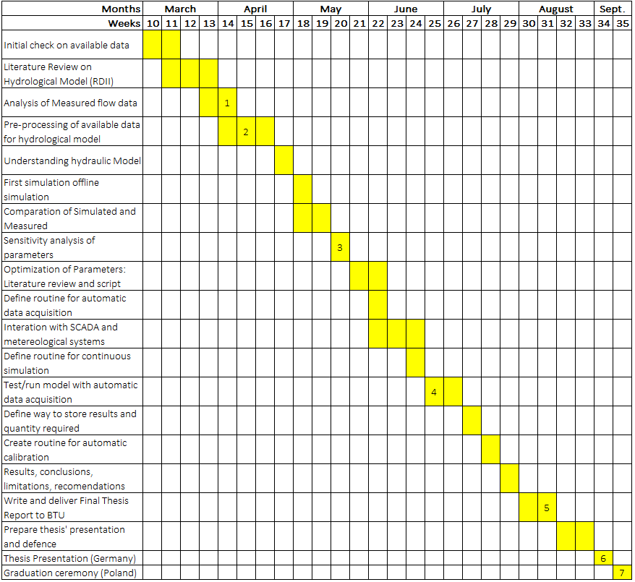

Table 1: Time Schedule

1. Inception Report (Online) 12.04.2019   
2. Master Thesis First Seminar (Online) 16.04.2019  
3. Master Thesis Second Seminar (Online) 23.05.2019  
4. Master Thesis Third Seminar (Online) 04.07.2019  
5. Final Thesis Report Submission (Online) 15.08.2019  
6. Master Thesis Presentation (Presential - Germany) 03.09.2019  
7. Graduation Ceremony (Presential - Poland) 09.09.2019

# HYDROLOGICAL MODEL

Flow in the sanitary sewer network can be classified as Dry-Weather Flow (DWF) and Wet-Weather Flow (WWF). DWF can be further divided in two components: 1. Base Waste Flow (BWF): inflow of waste water coming from households, commercial and industrial sites; and 2. Groundwater Infiltration (GWI): Water from aquifers that infiltrates into the network thought defects such as pipe cracks and leaky joints[1].

The choice of the hydrological model in this study aims the representation of RDII, which is the incremental flow into the sanitary sewer system caused by precipitation (rainfall or snowmelt). Figure 3 shows the typical characteristics of different components of sanitary sewer flow. RDII needs to be first separated from DWF when processing raw data coming from flow meters. More about the methods to separate the components are discussed on section 4.2.

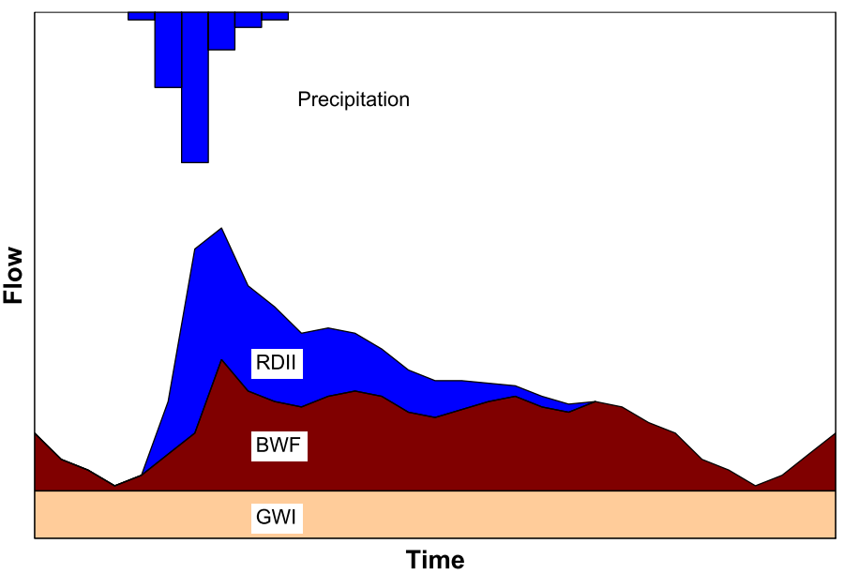

Figure 3: Components of wet-weather wastewater flow [1]

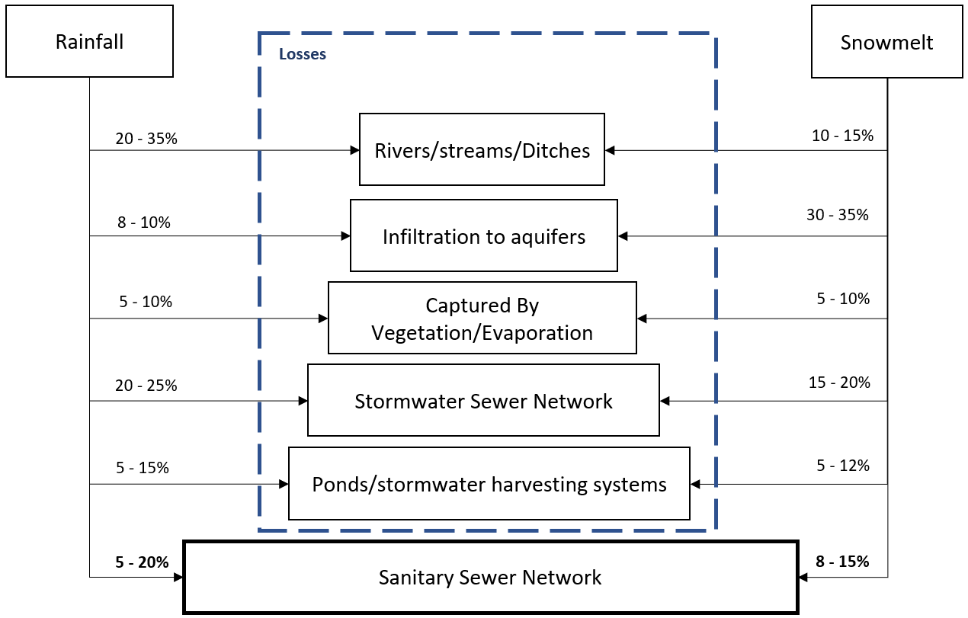

## Methods to Quantify Rainfall Dependent Infiltration and Inflow

As mentioned on section 1. There are different ways stormwater or snowmelt finds its way into the sanitary sewer lines which ideally would have only wastewater from urban developments such as households, commercial centers, factories, etc. The increase of the expected flow in sanitary sewer networks can be trigged by an event such as a storm or elevation of the groundwater table. From rainfall or snowmelt water flows over the soil surface and inflows to the sanitary sewer through manhole leaky covers or directly from roof-drain and foundation connections. The flow increases in the sanitary sewer due to inflow is generally observed few hours after the beginning of the storm or snowmelt. As depicted in figure X, rainfall or snowmelt Once the water infiltrates, it moves through the soil porous with a much slower velocity due to the characteristics of the groundwater flow. Infiltration of groundwater flow which reaches the elevation of pipe. Direct roof drain connections. Groundwater infiltration from saturated soil.

There are many processes where. Function of the infiltration, groundwater flow, surface runoff, flow through pipe fissures.   
  
Rainfall dependent infiltration and inflow have been modeled with different methods. Bennet (1999) [2]carried a literature review and case study of around 10different methods for quantifying RDII.

The study concluded that only the regression and unit hydrograph methods are suitable when applying continuous simulation for long-term modelling. The unit hydrograph (UH) method also provided the best consistent match to storm peaks. Vallabhaneni and Burguess (2007) [1] and U.S. EPA (2008) [13] also considered sewer network rehabilitation capabilities as a factor for evaluation of the methods and suggested that regression should be used when more than 2 years of recorded flow and rainfall data is available. When no flow is available, the Constant Unit Rate RDII Method seems to be useful since it accounts for spatial characteristics of the Sewershed and information of pipe characteristics and population. Moreover, U.S. EPA (2008) study concluded that Unit Hydrograph RTK method can be useful to identify if which portion of the wet-weather flow is caused by inflow and which portion is caused by infiltration. Knowing whether RDII is more impacted by inflow or infiltration is relevant when evaluating the sanitary sewer network for rehabilitation.

It is important to mention that the studies also concluded that there is no RDII quantification method that can be universally applied, since their use depend on available data and characteristics of the catchment. The goal of Vallabhaneni and Burguess (2007) [1] and U.S. EPA (2008) [13] reviews were to choose the most suitable method to be first implemented in a toolbox named as Sanitary Sewer Overflow Analysis and Planning (SSOAP).

SSOAP Toolbox developed by U.S. EPA has tools to support the quantification and management of RDII in sanitary sewer networks. These tools can be helpful and are relevant for this study. The RDII Analysis Tool available in the SSOAP Toolbox can identify and separate DWF and WWF, determine parameters for the set of Unit Hydrographs RTK, and perform statistical analysis of the parameters to non-measured catchments and design storms [1]. Other characteristics of SSOAP that can be considered time-saving for this study are: 1. free and open source; 2. Interface with SWMM 5.

Steps in SSOAP to decompose hydrograph provided by a flow meter - based on quick start manual

1. Create New SSOAP Database where all next items will be placed
2. Rainfall Data:

* *Management > Create Rainfall gauge*
* *Converter Setup > Create new converter* to read correctly values from Rainfall dataset.
* *Import* from available rainfall dataset (csv). Your OS must be set for comma and dot.

1. Flow Monitoring Data: Similar three steps as it was for Rainfall data
2. Use *Database Management > Utilities* to analyze flow and rainfall data
3. RDII Analysis Tool:

* **Identify Dry-Weather Flows:** *DWF Analysis > Automatic DWF > Choose parameters for weekday and weekends*. This will automatically exclude days with WWF. Holidays can also be left out of the analysis in *DWF Analysis > Holidays…*
* **Identify Groundwater Infiltration (GWI)**: *DWF Analysis > Identify Minimum Nighttime Flows*. This is done by finding minimum nighttime flows. According to SSOAP guide, 10% of the flow during minimum nighttime comes from wastewater and the rest through GWI. It is assumed the minimum nighttime occurs at 4 a.m. This may change according to the location.
* **Adjustments and view the data:** *DWF Analysis > Automatic DWF Adjustment Calculation* Difference between the average flow for the given day and the average flow of all DWF days selected on first step. Values can be negative and positive. This adjustment can be done to account for seasonal variations. Go for *DWF Analysis > View DWF Graph or Statistics* to check if the DWF data seems correct.
* **Identify Wet-Weather Flows:** *WWF Analysis > Automatic RDII Event Identification* Here the user defines which kind of rainfall will be considered as an event and which will be left out. This can be done by choosing a threshold such as: Peak, Volume or Duration. Access *RDII Graph* to graphically adjust the chosen rainfall events.

*In case RTK approach is the one chosen for this project, the instructions below may help to define constraints and obj. functions for DDS algorithm  
_________­_________­_________­_________­_________­_________­_________­_________­__________*

*Copied and pasted from SSOAP guide manual: Practices when defining RTK parameters*

*The* ***Consistency in Approach*** *help topic provides some examples on how RDII analysts can work consistently – a key objective of which is to provide more meaningful comparison of results. The following general guidelines may also be used when setting the unit hydrograph parameters for a flow monitor:*

*1. In general, the T and K parameters should be constant or similar for all events for a given meter.*

*2. T and K for the three triangular unit hydrographs should generally be applied as follows:*

*T1 less than T2 less than T3*

*(T1+T1*K1) less than (T2+T2*K2) less than (T3+T3*K3)*

*3. The need to change T and K for a particular event to match the observed flows is often a sign that the rainfall data being used is not representative of the rainfall that fell over the basin for the event.*

*4. The R values will vary from RDII event to RDII event. Generally, they are higher for wet antecedent moisture conditions and lower for dryer antecedent conditions. Some of this variation can often be reduced through refinement of the initial abstraction parameters. Very high or low values for a single event may be a sign that the rainfall being used is not representative or perhaps a RDII pathway is active or inactive under certain conditions. The latter may be determined by analyzing numerous events and identifying trends.*

*5. R-values are typically lower during dry AMC season and higher in wet AMC season due to seasonal influence. Often RTK evaluation will be performed for the two AMC seasons if data span the two seasons. The seasons tend to track well with annual groundwater variation. Between AMC seasons, TK should remain unchanged, but the R values are often significantly lower during growing periods than during wet AMC periods with much of the reduction in R coming from the delayed response i.e., the second and third unit hydrographs.*

*6. The first step when using fitting unit hydrographs should be to adjust the default curve R, T, and K values to obtain a gross fit for all events for a given meter. Then, R-values can be adjusted for individual events to obtain the best reproduction of the observed RDII flows.*

*Method Consistency Example Analysis of Continuous Record*

*1. Verify approach meets objectives. For this example, SWMM5 parameters are determined seasonally although SWMM5 resolution for parameters can be determined monthly. Note: due to limited number of events in a given month, monthly distinction may require a multi-year record to determine with any degree of confidence, and for a multi-year record would need to determine influence of annual variation.*

*2. Segregate analyses/results for comparison of seasonal/annual effects if spanning multiple seasons/years.*

*3. Vary GW Adjustment gradually*

*4. Focus on longest response event first to establish Ts and Ks, typically found in dormant season data*

*5. Use all three unit hydrographs*

*6. T1<T2<T3*

*7. (T1+T1*K1)< (T2+T2*K2) < (T3+T3*K3)*

*8. (UH1: minutes to hours)<(UH2: hours to day or so)<(UH3: day to week, likely no more than 10 days)*

*9. Keep Ts and Ks same or similar for all seasons*

*10. Within season, identify events with wet antecedent conditions and determine R1, R2, R3. For the likely reduction in R-values in dry AMC season relative to wet AMC season, R3 will likely reduce the most, followed by R2, then R1. (AMC = Antecedent Soil Moisture Condition)*

*11. Within season, with RTKs now fixed. Adjust the three IA parameters, for all events spanning completely dry to fully saturated antecedent conditions.*

*­_________­_________­_________­_________­_________­_________­_________­_________­__________*

SSOAP: It is possible to export .csv file with GWI, BWF, DWF, Observed FLOW, and RDII flow.

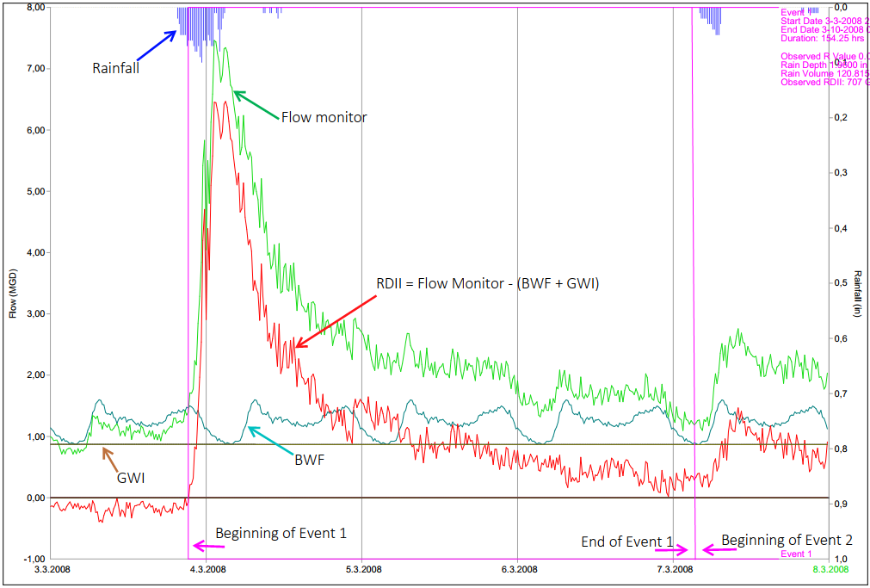

The time and shape of the hydrograph is relevant for the purpose of the model. Therefore, methods of constant unit rate, R-value, and….. are not suitable.

Conclusions of the literature review:

Furthermore, [14] compared RDII unit hydrograph approaches for continuous simulation and concluded…

Include here results from case studies of the use of RDII methods: this can be found in [15] and [2]

Search Space of

* What is a significant rainfall event to consider when separating RDII from BWF, GWF ? Crawford et al. (2015) mention that typically events greater than 25mm of rainfall are used when deciding significant rainfall events. Check what Gheith 2015 thinks

Snowmelt Dependent Infiltration and Inflow

## Sewershed Delineation

**Subcatchment/Sewershed delineation**

How to divide sewershed?

Below table of comparison made by [16]

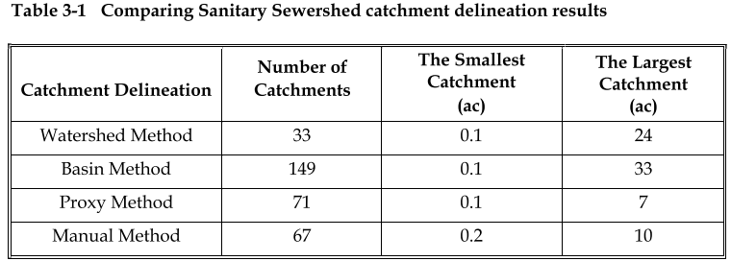

mention DWF Sewershed and WWF Sewershed in thesis and their differences. [17]. Try to calculate how many sewershed are available if all the pipes are to be considered (count the amount of pipes) – this is to justify using some tool available (QGIS) and develop a set of operations with (ModelBuilder)

Subcatchment delineation depend on the purpose of the model [4]. A greater number of subdivisions of the area should be used to acquire a more pipe/channel specific simulation. Thus, when the purpose of the model is to analyze the flow behavior on a specific junction of a sewer network, the subcatchment (area) being drained to this point should be delineated creating one division to each junction/drainage point of the sewer network system.

The purpose of this study is to model rainfall dependent infiltration inflow (RDII) in the sewer network. A more detailed approach would be to delineate a subcatchment for each drainage point as described above. However, historical data (hydrographs) should be available for each of the drainage points to compare the results of the simulation against the measured and calibrate parameters to better describe the response of the subcatchment to rainfall or snowmelt.

For this study, data was available only at some pump stations. Therefore, a subcatchment delineation considering the sewer network pump stations as the only drainage point of a subcatchment was used as initial approach as shown in figure x. This delineation assumes that water from rainfall and snowmelt flows overland straight to the pump stations, before being drained to the manholes/junctions upstream which happens.

Three distinct catchment delineations may be used to simulate the hydrographs of each pump station.

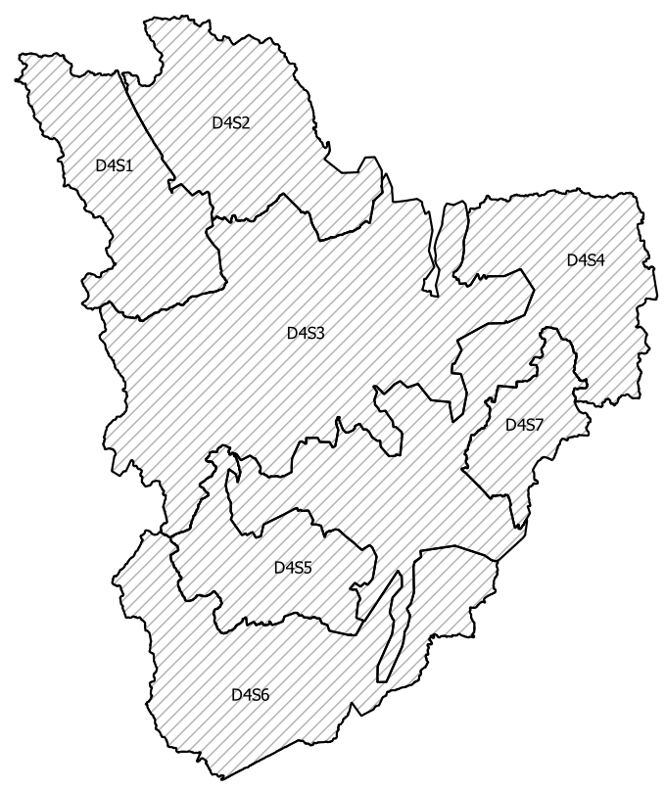

There are 4 different catchment delineations and they are numbered as follows:

1- Pumping stations (PS) and DEM

2- Buffered Over Diameter x 555

3- PS DEM limited by 0.5km Buffer

4- PS DEM and Buffered over Diameter x 555 (combination of 1 and 3)

The sanitary sewer catchment of Jokela town was divided into 7 parts.

One for each pumping station and are numbered as follows:

1- Tarkoja Sewershed

2- Virtalantie Sewershed

3- Tehtaantie Sewershed

4- Jokela Sewershed

5- Kartano Sewershed

6- Pappilantie Sewershed

7- Peltokaari Sewershed

0- All sewersheds together

## Proposed Hydrological Model: RTK UH and Snowmelt

Rainfall Dependent Inflow and Infiltration (RDII)

Flows are higher than average into the sanitary or combined sewer network during and after a storm. This incremental quantity of stormwater *inflows* into the network from roof drain connections, foundation connections, leaky manhole covers, etc. [4] The *inflow* causes a relatively high peak discharges in the network in a short term, usually while the storm is happening. A bit less intuitively, flows and depths remain higher than average in the network after the rainfall event ranging from hours to even weeks [3]. This long term is caused by *Infiltration* of stormwater that enters the network system through defects such as damage pipes and joints [4]. Stormwater infiltrates the network after percolating through the soil. Groundwater also infiltrates into the network due to water table elevation caused by wet periods.

To simulate the inflow & infiltration caused by a rainfall event, SWMM incorporates the synthetic unit hydrograph RTK method. This unit hydrograph was first created to simulate RDII, therefore it accounts for the short, medium- and long-term effects. This model creates three triangular unit hydrographs, one for each term. Unit Hydrographs are then summed to create a final unit hydrograph that simulates the overall response of the system as shown in figure X. The letters R-T-K refers to the parameters used to create the triangular hydrographs and are, respectively, fraction of precipitation that enters the network (area below hydrograph), time to peak, and recession time.

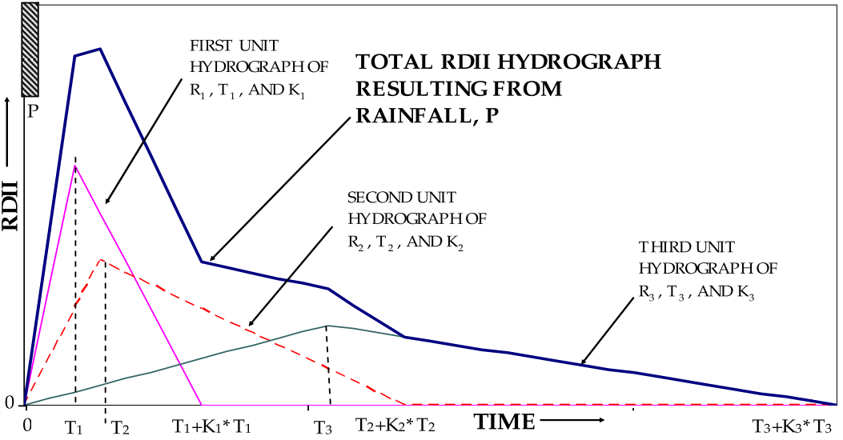

Figure X: Summation of Three Unit Hydrographs (Vallabhaneni et al., 2007)

This method accounts for hydrograph time and shape and is capable of handle multiple storms, multiple sewershed types, system ages, and seasonal influences. [1]

Losses: example of how much water is captured by vegetation: winter when the leaves are gone it captures less so, more water can be available to flow into sanitary sewer network.

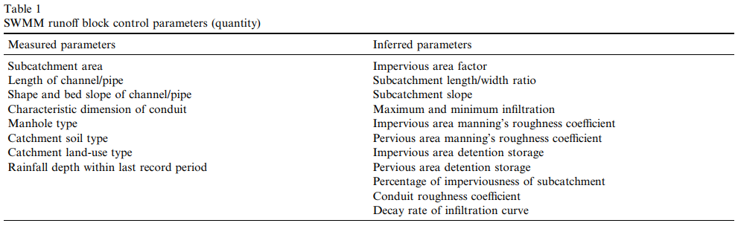From: **Parameter estimation for urban runoff modelling (2001)**

Losses

Snowmelt

SNOTMP is a temperature parameter that divides precipitation input into snowfall or rainfall. Rossman 2016 [4] suggests a lower temperature for urban areas in comparison with rural catchments which uses a range from 1 to 2°C. For this study, a range from 0 to 1°C was chosen.

## Parameter Estimation

Physically meaningful range for all design variables? R, T, K, Dmax, Drec, Do

**R:**

the fraction of rainfall volume that enters the sewer system and equals the volume under the hydrograph

RxAx

0.0042 (sum of R values) – 0.4% of rainfall volume  
Area: 1355 ha / ~190 soccer fields  
Delineation: D4

0.0104 (sum of R values) – 1% of rainfall volume  
Area: 548.5 ha / ~80 soccer fields  
Delineation: D2

**T:** the time from the onset of rainfall to the peak of the unit hydrograph

**K:** the ratio of time to recession of the unit hydrograph to the time to peak

**Dmax:** the maximum depth of initial abstraction available (in rain depth units)

**Drec:** Recovery rate. The rate at which any utilized initial abstraction is made available again (in rain depth units per day)3

**Do:** the amount of initial abstraction that has already been utilized at the start of the simulation (in rain depth units).

As stated by (Vallabhaneni and Burgess 2007) R-values are proportional to the sewershed delineated area. This relation can be seen by the comparison table X of R-values for four different sewershed delineation of Jokela’s catchment proposed on the previous section. Taking as example the sewershed D4 (largest) and D1 (smallest) of the previous section. The fraction of rain falling over the D4 area that finds its way into the sewer system is smaller than the fraction of D1. As depicted in Equation X, R-values are calibrated to be further multiplied by the sewershed area resulting the desired volume entering the pipe network.

Precipitation input data is another factor influencing the estimation of R-values. In case precipitation measurements used for calibration of R-values fails to capture the realistic volume falling over the sewershed, estimated R-values will also represent erroneous fractions of the precipitation entering the sanitary sewer network.

(Paragraph with references) Radar x Rain gauge x combination of both. Vallabhaneni and Burgess 2007.

Although distinct precipitation measurements lead to different R-values. rain gauges and radar in some cases do capture similar rainfall pattern as concluded by [18]. Therefore, both rain gauge and radar may yield similar T and K estimated values.

In summary, R-values are influenced by sewershed area, precipitation input, network and catchment’s characteristics //include network characteristics that influences R-values such as aging, defects, etc.

RTK event based. Manually calibrate RTK parameters for each rainfall of the period without snowmelt of 2018 for Jokela catchment. Linear regression available in SSOAP toolbox was first used to determine the relationship between the rainfall volume and R-values.

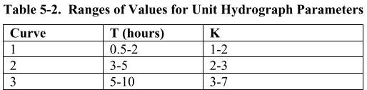

We can use T and K as proposed by Vallabhaneni et al. and R based on first calibration. (ex. Manually calibrate three Sewersheds upstream tehtaantie ps and find the maximum Total R value. Consider it was R-20%. Divide 20% proportionally to the sewershed areas. Ex. S1 Rmax1 = 10%, S2 Rmax2 = 5%, S3 Rmax3 = 5%. Do a similar process to find Rmin values. From that, define the range. Give these limits to the optimization algorithm.

Do similar for the sewersheds upstream Jokela Ps. (Jokela Flow – Tehtaantie Flow).

Separate the calibration of each sewershed to leave room for further analysis when flow meters will be installed to each storage unit.

The process of finding the R-max and R-min during the calibration process could also be automatized. What was the R-max assigned to an event for the period from May to November? What was the R-min? If the calibration process will be repeated monthly, by the end of the period (November) the 6 months data with each R-value calibrated for each event would be gathered and summed up with the previous years. R-min and R-max could be then fetched from this database and stored for the next calibrations.

# HYDRAULIC MODEL

## Demand estimation

## Forecast Estimation

# DATA AND CASE STUDIES

Article of Decision support system for combined overflow [19]

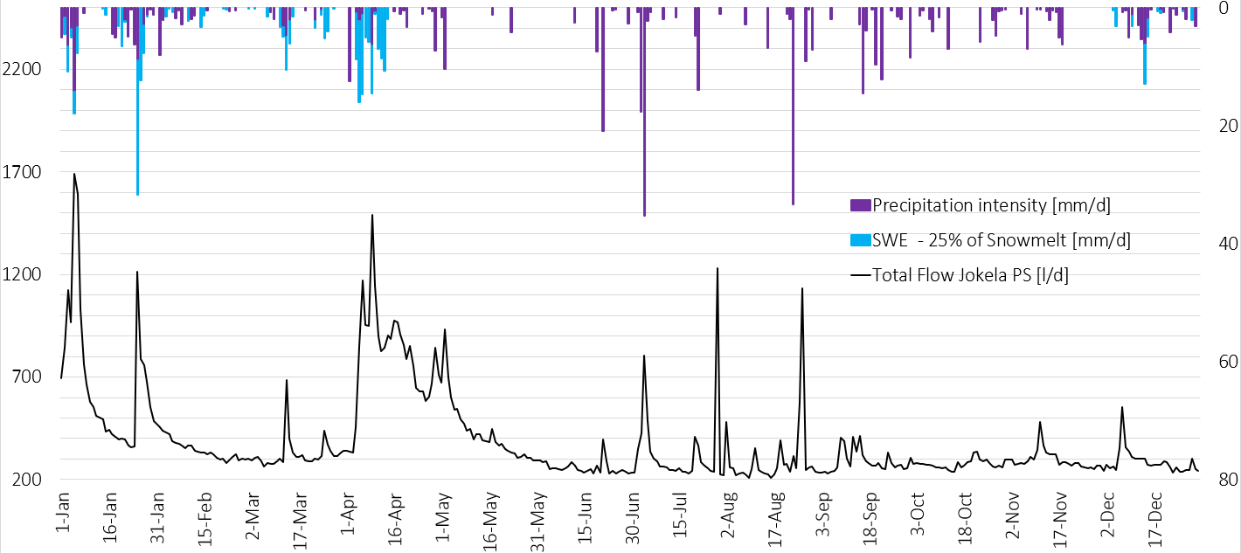

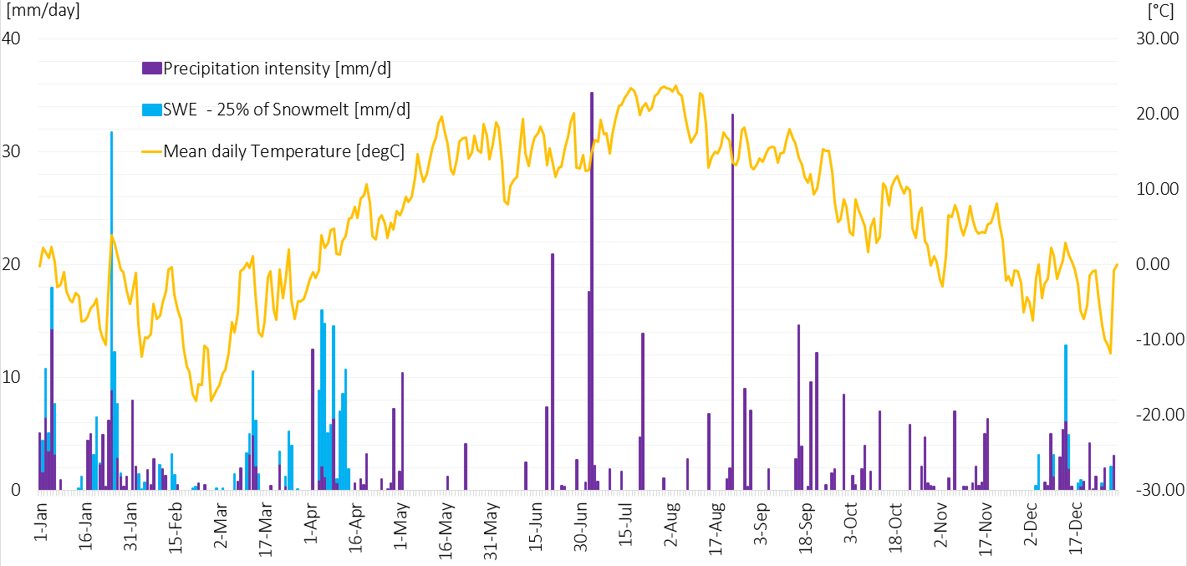

## Data

**Pre-processing**

Two main data sets were used during the model calibration: 1. Digital Elevation Model (DEM) and 2. Precipitation as point and grid data.

The DEM used is this study was provided by the National Land Survey of Finland (NLS) as 2m x 2m resolution based on laser scanning data collected in the summer of 2015. The vertical resolution varies from 0.3 to 1 meter (NSL, 2019).

**Rainfall**

**Hindcast:**FMI - Radar

Query to get link for the data: <http://opendata.fmi.fi/wfs?service=WFS&version=2.0.0&request=getFeature&storedquery_id=fmi::radar::composite::rr>

Metadata:  
<http://catalog.fmi.fi/geonetwork/srv/eng/catalog.search#/metadata/b8105f88-fa49-4d26-9b92-eb269d2c8e18>

Link for downloading directly the data:

<http://wms.fmi.fi/fmi-apikey/16161ed5-21aa-4c0e-9c9c-5c4facf87d0a/geoserver/Radar/wms?service=WMS&version=1.3.0&request=GetMap&layers=Radar:suomi_rr_eureffin&styles=raster&bbox=-118331.366,6335621.167,875567.732,7907751.537&srs=EPSG:3067&format=image%2Fgeotiff&time=2019-05-09T10:50:00Z&width=1987&height=3144> – note that Johan’s API key is being used  
rainfall intensity (rr), conversion: rr[mm/h] = 0.01 * pixel value

1 hour precipitation (rr1h), conversion: rr1h[mm] = 0.01 * pixel value

<http://wms.fmi.fi/fmi-apikey/16161ed5-21aa-4c0e-9c9c-5c4facf87d0a/geoserver/Radar/wms?service=WMS&version=1.3.0&request=GetMap&layers=Radar:suomi_rr1h_eureffin&styles=raster&bbox=384237.338,6710848.381,391921.243,6718990.700&srs=EPSG:3067&format=image%2Fgeotiff&time=2019-05-02T21:00:00Z&width=850&height=1345> – limits the area for Jokela town

FMI – Point Observation  
Webpage Download Service for Point Observation:

<https://en.ilmatieteenlaitos.fi/download-observations#!/>

WFS: has the limit of 7 days:

<http://opendata.fmi.fi/wfs?service=WFS&version=2.0.0&request=getFeature&storedquery_id=fmi::observations::weather::timevaluepair&fmisid=101130&timestep=60&parameters=r_1h&starttime=2018-01-02T09:00:00Z&endtime=2018-01-09T09:00:00Z> i.e. rain amount from 02.01.18 to 07.01.18

TMS digitraffic does not provide precipitation historical data

**Nowcast:**FMI  
<http://opendata.fmi.fi/wfs?service=WFS&version=2.0.0&request=getFeature&storedquery_id=fmi::observations::weather::timevaluepair&fmisid=101130&parameters=r_1h,ri_10min,t2m&timestep=60>

T2m = temperature; RI_10min = Rainfall intensity 10min interval; r_1h= RainfallAmount(avg(ri_10min)); fmisid 101130 = hyvinkää hyvinkääkylä  
By default returns the last 12 hours

TMS  
Traffic Management Finland (TMF Digitraffic): <https://tie.digitraffic.fi/api/v1/data/weather-data>  
precipitation intensity(Sensor id 23) precipitation amount (Sensor ID 24), type of precipitation (Sensor ID 25). Nearest station to Jokela 1147, 1020, 1069, 1018, 1151, 1152Metadata of sensors: <https://tie.digitraffic.fi/api/v1/metadata/weather-sensors>  
Metadata of stations: <https://tie.digitraffic.fi/api/v1/metadata/weather-stations>  
Metadata is in geojson – stations and roads can be easily visualized with Qgis. **Forecast:**

FMI  
  
<http://opendata.fmi.fi/wfs?service=WFS&version=2.0.0&request=getFeature&storedquery_id=fmi::forecast::harmonie::surface::point::timevaluepair&latlon=60.56309,24.9435&parameters=PrecipitationAmount&timestep=60>

Harmonie runs 4 times a day (00, 06, 12 and 18 UTC) – finnish local time (03, 09, 15 and 21 Eastern European Summer Time)

**probability forecast available from FMI webpage (i.e. 80% chance of rain) provided by <https://www.ecmwf.int/en/forecasts/accessing-forecasts> and not free for commercial use.

TMS

Traffic Management Finland (TMF): <https://tie.digitraffic.fi/api/v2/data/road-conditions>/45  
12h weather forecast for road segments with 2h interval. Nearest segments of roads to Jokela are: [00045_009_00000_0_0, 00045_010_00000_0_0]  
Metadata of the roads (geojson): <https://tie.digitraffic.fi/api/v2/metadata/forecast-sections>   
  
PrecipitationCondition can get the values 0 - 7 as follows:

0 = no data available

1= rain intensity < 0.2 mm/h (NO_RAIN_DRY_WEATHER)

2= rain intensity >= 0.2 mm/h (LIGHT_RAIN)

3= rain intensity >= 2.5 mm/h (RAIN)

4= rain intensity >= 7.6 mm/h (HEAVY_RAIN)

5= snowing intensity >= 0.2 cm/h (LIGHT_SNOWFALL)

6= snowing intensity >= 1 cm/h (SNOWFALL)

7= snowing intensity >= 3 cm/h (HEAVY_SNOWFALL)

more info about digitraffic APIs:  
<https://tie-test.digitraffic.fi/api/v1/metadata/documentation/swagger-ui.html#!/Data32v2/roadConditionsUsingGET_3>  
<https://www.digitraffic.fi/en/road-traffic/>

more info about digitraffic Open Data: <https://tmfg.fi/fi/node/161>

**General: Rain gauges were available surrounding the pilot areas.**

**Pilot Area 1: There were two rain gauge stations around 15km**

**Hyvinkää Hyvinkäänkylä**

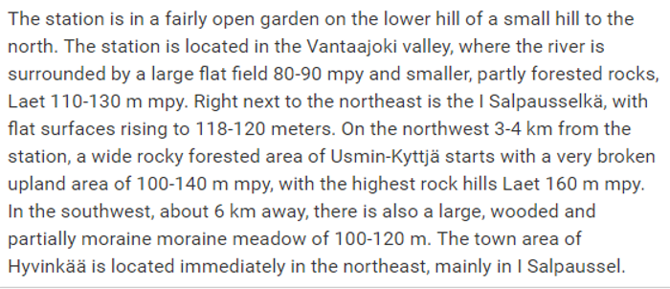<https://ilmatieteenlaitos.fi/havaintoasemat>

**Mäntsälä Hirvihaara**

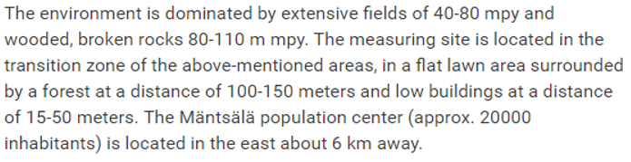

**Järvenpää seems to be available only from 2018-11-11**

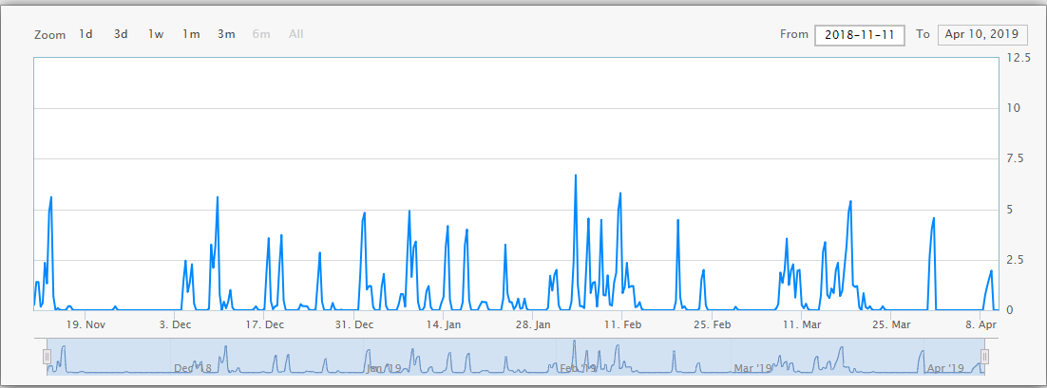

**Hyvinkaa**

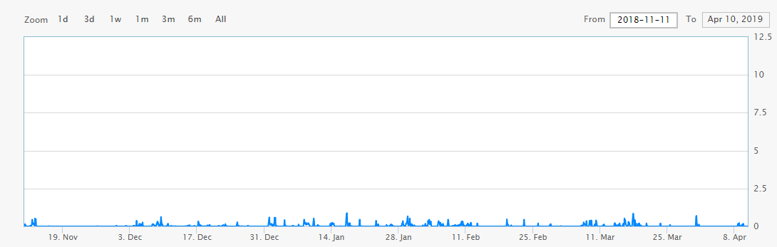

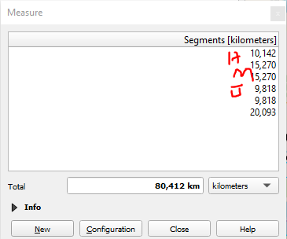

**389737,0189900000**

**6713836,3929000003**

**Lowest area according to DEM is 53.983 m**

**Snowmelt**

Simulate and forecast

Inputs:

Weather forecast 2 x 2km grid:  
Temperature and Rainfall intensity

Historical Data  
station inflow, outflow, temperature and rainfall intensity   
Weather measurements: Snow depth, temperature, rainfall intensity

**SWMM Inputs:**

**Qgis:**   
areas of subcatchments   
slope   
Length of creeks/channels  
width (different ways to calculate but mostly dependent on the longest flow path and area of the subcatchment) w=1/length, w=area/length - check swmm manual  
Catchment Soil Type  
Catchment Land-use type  
Maybe estimate impervious and pervious area percentage for each subcatchment  
Maybe some pre-processing for rainfall data (area of influence e.g. thiessen polygon)

**From hydraulic model/data:**

Manhole type  
Conduit roughness coefficient  
Characteristic dimension of conduit

**Literature:**

Mannings (for impervious, pervious area and natural channels)  
DStore (impervious and pervious)  
Maximum and minimum infiltration  
Decay rate of infiltration curve

Useful map of finland with many layers and their sources

<https://en.ilmatieteenlaitos.fi/weather/tuusula/jokela>

FMI

<https://en.ilmatieteenlaitos.fi/weather/tuusula/jokela>  
https://en.ilmatieteenlaitos.fi/download-observations#!/

Snow Statistics - <https://en.ilmatieteenlaitos.fi/snow-statistics>  
News and reports - <https://ilmatieteenlaitos.fi/tiedotearkisto?p_p_id=announcement_WAR_fmiwwwportlets&p_p_lifecycle=0&p_p_state=normal&p_p_mode=view&p_p_col_id=column-4&p_p_col_count=2&_announcement_WAR_fmiwwwportlets_year=2018>

Info about weather obs stations - <https://ilmatieteenlaitos.fi/havaintoasemat>  
 <https://ilmatieteenlaitos.fi/havaintosuureet>

Data retrieval examples <https://ilmatieteenlaitos.fi/latauspalvelun-pikaohje>

DEM - NLS

<https://tiedostopalvelu.maanmittauslaitos.fi/tp/tilaus/bhtsfqjs0qkkp36lrjasljht30?lang=en>

<https://tiedostopalvelu.maanmittauslaitos.fi/tp/tilaus/631399qak7intuq86trjfbk0qk?lang=en>

Landuse

<https://ilmastotyokalut.fi/files/2014/07/ilmakuvauksen_menetelmakuvaus.pdf>

<https://dspace.cc.tut.fi/dpub/bitstream/handle/123456789/23632/Lahti.pdf?sequence=1>  
<http://geoforum.fi/wp-content/uploads/2018/11/LBF2018_Rakennus2_Mikko_Pusa_HSY.pdf>

SYKE

<http://paikkatieto.ymparisto.fi/lapio/latauspalvelu.html>

<https://www.vesi.fi/>

Metadata info - <http://metatieto.ymparisto.fi:8080/geoportal/catalog/main/home.page;jsessionid=72118CFCE4D6047D0BF06A5784766E79>

How to refer to SYKE data: <https://www.syke.fi/fi-FI/Avoin_tieto/Nain_viittaat_SYKEn_avoimen_tiedon_palve(37794)>

|  |  |  |
| --- | --- | --- |
| SWMM INPUT | Obtained by | File name |
| Subcatchment area | qgis |  |
| Length of channel/pipe | Qgis(stream) - F.Storm(pipe) |  |
| Shape and bed slope of channel/pipe | Qgis(stream) - F.Storm(pipe) |  |
| Characteristic dimension of conduit | F.Storm |  |
| Manhole type | F.Storm |  |
| Catchment Soil type | Geological Survay of Finland - [GTK](http://www.gtk.fi/)Geologian Tutkimuskeskus  <https://hakku.gtk.fi/en/locations/search> | Geology > Superficial Deposits of Finland 20K or 50K |
| Catchment land-use type | Urban Atlas map 2012 -  <https://land.copernicus.eu/local/urban-atlas/urban-atlas-2012?tab=mapview> |  |
| Rainfall depth within last record period |  |  |
| Impervious area factor |  |  |
| Percentage of imperviousness by subcatchment | -https://land.copernicus.eu/pan-european/high-resolution-layers/imperviousness/status-maps/2015  Combine Urban atlas map data and catchment delination in GIS | Grundfos - WWNC\B Input data\Pre-processing\QGIS\Imperviousness percentage |
| Subcatchment lengh/width ratio (choose one formula) | Qgis |  |
| Subcatchment slope | qgis |  |
| Maximum and minimum infiltration |  |  |
| Decay rate of infiltration curve |  |  |
| Mannings (for impervious, pervious area and natural channels) |  |  |
| DStore (impervious and pervious) |  |  |

Forecast

About forecast models <https://en.ilmatieteenlaitos.fi/weather-forecast-models>

There are two models used for forecast. HARMONIE and RCR HIRLAM. Data is available as grids (raster) and as Time Series. <https://ilmatieteenlaitos.fi/avoin-data-saaennustedata-hirlam>

RCR HIRLAM - <http://catalog.fmi.fi/geonetwork/srv/eng/catalog.search#/metadata/43282657-3329-4c82-bd31-2631f41357f5>

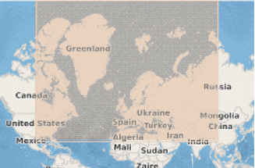

* Weather variables and rainfall up to h + 48h
* Updated every 6 hours
* Grid Resolution 7,5km

HARMONIE - <http://catalog.fmi.fi/geonetwork/srv/eng/catalog.search#/metadata/56eac114-43e9-4cae-922d-d4f486728fb1>

<https://www.smhi.se/en/research/research-departments/climate-research-rossby-centre2-552/harmonie-1.135580>

<http://hirlam.org/index.php/hirlam-programme-53/general-model-description/mesoscale-harmonie>

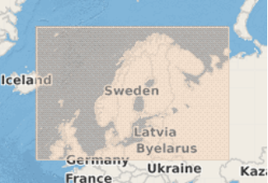

* Weather variables and rainfall up to h+ 66h
* Updated every 6 hours
* Grid Resolution 2,5km
* Lambert’s projection

Weather forecast will be requested from Finnish Meteorological Institute (FMI) servers.

<http://catalog.fmi.fi/geonetwork/srv/eng/catalog.search#/home> - catalog of available data

<https://en.ilmatieteenlaitos.fi/open-data-manual-accessing-data> - manual to access data

<https://en.ilmatieteenlaitos.fi/open-data-manual-fmi-wfs-services> - Open Data WFS Services: available data and parameter per queries

<https://en.ilmatieteenlaitos.fi/open-data-manual-wfs-examples-and-guidelines> - WFS Examples & Guidelines

<https://en.ilmatieteenlaitos.fi/open-data-manual-forecast-models> - Gridded Numerical Forecast Data

<https://ilmatieteenlaitos.fi/latauspalvelun-pikaohje> - quick guide to download service

* <https://en.ilmatieteenlaitos.fi/open-data-manual-time-series-data> - Time Series Data and MetOlib for JavaScript.   
  Point Forecast can be requested based on the location. For example, for Turku. [https://opendata.fmi.fi/wfs?service=WFS&version=2.0.0&request=getFeature&  
  storedquery_id=fmi::forecast::hirlam::surface::point::multipointcoverage&  
  place=turku&](https://opendata.fmi.fi/wfs?service=WFS&version=2.0.0&request=getFeature&storedquery_id=fmi::forecast::hirlam::surface::point::multipointcoverage&place=turku&)

or to get time value pair for Jokela with 15min time step  
<http://opendata.fmi.fi/wfs?service=WFS&version=2.0.0&request=getFeature&storedquery_id=fmi::forecast::harmonie::surface::point::timevaluepair&place=jokela&timestep=15&> - This will return all the forecasted parameters for the closest weather observation point from Jokela. The station code is also available, for ex 655758 in this case.

<http://opendata.fmi.fi/wfs?service=WFS&version=2.0.0&request=getFeature&storedquery_id=fmi::forecast::harmonie::surface::point::timevaluepair&place=jokela&timestep=15&parameters=Temperature,PrecipitationAmount&> - This will return only temperature and precipitation forecast for Jokela

[http://opendata.fmi.fi/wfs?service=WFS&version=2.0.0&request=DescribeStoredQueries&  
storedquery_id=fmi::forecast::harmonie::surface::point::timevaluepair&](http://opendata.fmi.fi/wfs?service=WFS&version=2.0.0&request=DescribeStoredQueries&storedquery_id=fmi::forecast::harmonie::surface::point::timevaluepair&) - Describe the stored queries

<http://opendata.fmi.fi/download?producer=harmonie_scandinavia_surface&param=Temperature,PrecipitationAmount&bbox=24.86102,25.09754,60.47196,60.6072546855907&origintime=2019-04-26T00:00:00Z&starttime=2019-04-26T00:00:00Z&endtime=2019-04-26T10:00:00Z&format=grib2&projection=EPSG:4326&levels=0&timestep=60> – Download grid forecast in grib2 format

<http://opendata.fmi.fi/download?producer=harmonie_scandinavia_surface&param=Temperature,PrecipitationAmount&bbox=24.86102,25.09754,60.47196,60.6072546855907&origintime=2019-04-26T00:00:00Z&starttime=2019-04-26T00:00:00Z&endtime=2019-04-26T10:00:00Z&format=grib2&projection=EPSG:4326&levels=0&timestep=60>

**Weather observations for cities as time value pairs. (fmi::observations::weather::cities::timevaluepair)**

**http://opendata.fmi.fi/wfs?service=WFS&version=2.0.0&request=getFeature&storedquery_id=fmi::observations::weather::cities::timevaluepair&place=Jokela**

**http://opendata.fmi.fi/wfs?service=WFS&version=2.0.0&request=DescribeStoredQueries&  
storedquery_id=fmi::observations::weather::cities::timevaluepair&place=Jokela**

**Instantaneous Weather Observations (fmi::observations::weather::timevaluepair)**

<http://opendata.fmi.fi/wfs?service=WFS&version=2.0.0&request=getFeature&storedquery_id=fmi::observations::weather::timevaluepair&fmisid=101130> – get data. For Jokela, it may be better to use a specific station id in the queries instead of its name since it returns Järvenpää station which seems not to be fully operational yet.

<http://opendata.fmi.fi/wfs?service=WFS&version=2.0.0&request=DescribeStoredQueries&storedquery_id=fmi::observations::weather::timevaluepair> – info about instantaneous dataReal time weather observations from weather stations. Default set contains air temperature, wind speed, gust speed, wind direction, relative humidity, dew point, one hour precipitation amount, precipitation intensity, snow depth, pressure reduced to sea level and visibility. By default, the data is returned from last 12 hour. At least one location parameter (geoid/place/fmisid/wmo/bbox) has to be given. The data is returned as a time value pair format.

(viesti on kirjoitettu englanniksi)

Hi. I am trying to get weather observation and forecast data for Jokela town located in Tuusula Municipality for a hydrological model.

Questions:

1. Is it reasonable to use precipitation data from weather observation station FMISID 101130 or FMISID 103794 for Jokela Town? In case not, what would be the alternatives to obtain hourly historical precipitation data for 2018 year specifically for Jokela Town.

2. Forecast data is also available as Time Series in your open data services. When requesting data for Jokela Town, your server returns that the information comes from station geoid 655758 (example of query described below). Is there more information available on how data is "converted" from Grid to Time Series? Would this example of query return the most suitable available weather forecast for Jokela Town?

Below additional information about the questions...

_______________________________________

1. Historical Data [Precipitation, Snow depth, Air Temperature].

- I found two weather observation stations within 20km radius from Jokela Town (link for map provided at the end of this message):

Station FMISID 101130: Hyvinkää Hyvinkäänkylä

Located around 10km from Jokela

Station FMISID 103794: Mäntsälä Hirvihaara

Located around 20km from Jokela

Purpose:   
Data will be used to calibrate Urban hydrological Model.

Notes:   
Minimum recording interval of 1h of at least the whole year of 2018. For this reason, the station (FMISID 103786: Jarvenpää Sorto) seems to be not suitable since no available data for 2018 was found.

2. Forecast Data [Precipitation , Air Temperature]

Example of query for Harmonie Model as TimeValuePair for Jokela Town with 15min interval:

__________________________________________

http://opendata.fmi.fi/wfs?service=WFS&version=2.0.0&request=getFeature&storedquery_id=fmi::forecast::harmonie::surface::point::timevaluepair&place=jokela&timestep=15&

__________________________________________

Purpose:

Data will be input for hydrological model to provi de forecast of flows in sanitary sewer network.

Link for Map with Jokela Town and Weather Stations:

https://drive.google.com/file/d/16QdTEeeL2s0RBzSDUAr0qHEkbqaLX5BG/view?usp=sharing

Thank you in advance for your help,

Please contact me in case more description is needed.

Pedro Almeida

0465452367

(viesti on kirjoitettu englanniksi)

Hello, I have been accessing model forecast timeseries as timeValuePair from your open WFS and realized that the values of PrecipitationAmount returned are different than the values provided in your website for PrecipitationAmount and the same location. Values for precipitation amount fetched from your open service WFS were overestimated in comparison to the values available in your webpage for both Hirlam and Harmonie.

I have been checking the forecast in your website for Jokela hourly here:

__________________________________________

https://en.ilmatieteenlaitos.fi/weather/tuusula/jokela?forecast=short

__________________________________________

Link used to request model forecast as timeSeries and timeValuePair:

__________________________________________

http://opendata.fmi.fi/wfs?service=WFS&version=2.0.0&request=getFeature&storedquery_id=fmi::forecast::harmonie::surface::point::timevaluepair&place=Jokela&parameters=PrecipitationAmount&timestep=60

__________________________________________

Example of Data checked at 08h50 of 03.05.2019:

Forecast in WFS for 11h00: 0.21 mm

Forecast in Webpage for 11h00: 0.0 mm

Notes: I am aware that the returned values for WFS is in UTC time zone. I also used three different locations requesting in your WFS for the vicinity of Jokela Town and all produced overestimated values in comparison to your Webpage (GeoName latlon, Station FMISID 101130, and center of Jokela).

Questions:

1) Which forecast should I rely on, the one provided by the WFS or the Webpage?

2) How can I have access to the same forecast used in your webpage? Is there a query available in your WFS for this forecast?

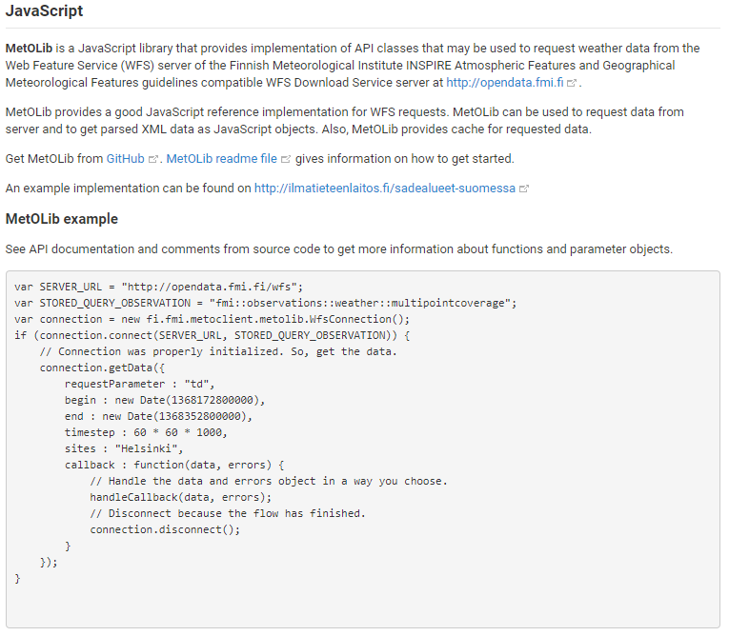

Harmonie Scandinavia Hybrid Weather Forecast Data is available on the following formats:

* Harmonie Scandinavia Surface Level Weather Forecast as Grid data (fmi::forecast::harmonie::surface::grid)
* Harmonie Surface Point Weather Forecast as multipointcoverage (fmi::forecast::harmonie::surface::point::multipointcoverage)
* Harmonie Surface Point Weather Forecast as simple features (fmi::forecast::harmonie::surface::point::simple)
* **Harmonie Surface Point Weather Forecast as time value pairs (fmi::forecast::harmonie::surface::point::timevaluepair)**

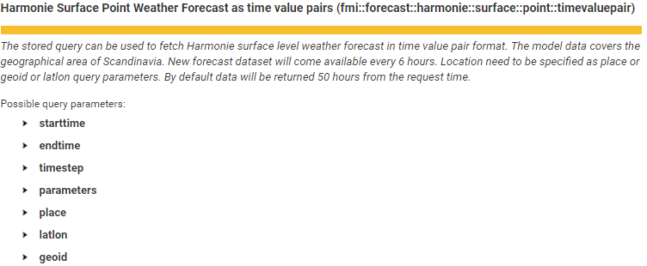

## Pre-processing

(sensitive information that should be available only for fluidit)

Raw data had to be treated to a readable format for SWMM. Figure X has an example of raw flow data of a pumping station in Jokela sanitary sewer network.

Jokela pumping station data

TS of flow measurements from 4 pumping stations  
- Time window: 1 year (2018)  
- Regular time steps: 1 hour  
- Extreme values? Mean values? Standard deviation?

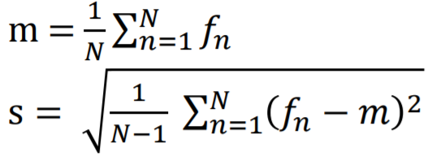

* Simulation time-step. It would be interesting to automatically detect the catchment’s response time (check if other software packages do this). The simulation time-step could be a function of the catchment’s response if stability criteria is assured.

Response time: after rainfall start how long will it take to observe an increase of the flow in response to the perturbation.

## Jokela Town

About Tuusula water>

<https://www.tuusula.fi/sivu.tmpl?sivu_id=7480>

<https://kartta.tuusula.fi/>

– background of the region such as: Location, climate, seasons, temperature, characteristics of rainfall, basin, soil type, streams, mean annual precipitation, tell about the rain gauges and give their location in lat lon and fmisid as well as radar, /tell that GWF was neglected at first.

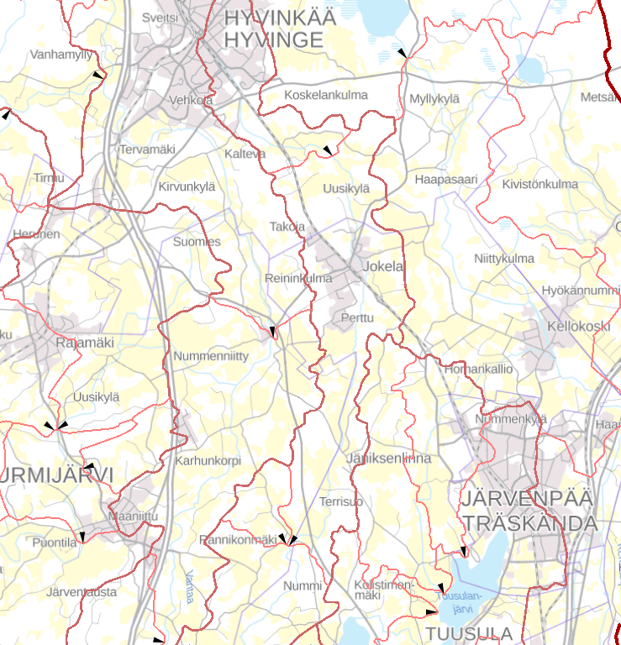

Natural catchment delineation. http://paikkatieto.ymparisto.fi/lapio/latauspalvelu.html

Data available – data available of the region.

Hydrology – Describe the method (RDII) and why it was chosen for this catchment.

Hydraulic – physical and hydraulic characteristics of the of the sewer network: Manholes, pumping stations, length of the network, flows and base wastewater flow (BWF), age of the sewer network. Try to find data of storm water network.

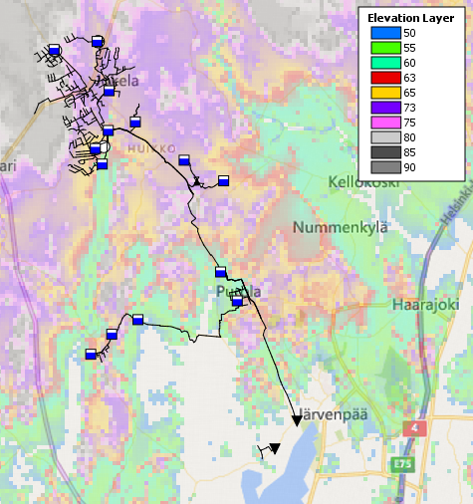

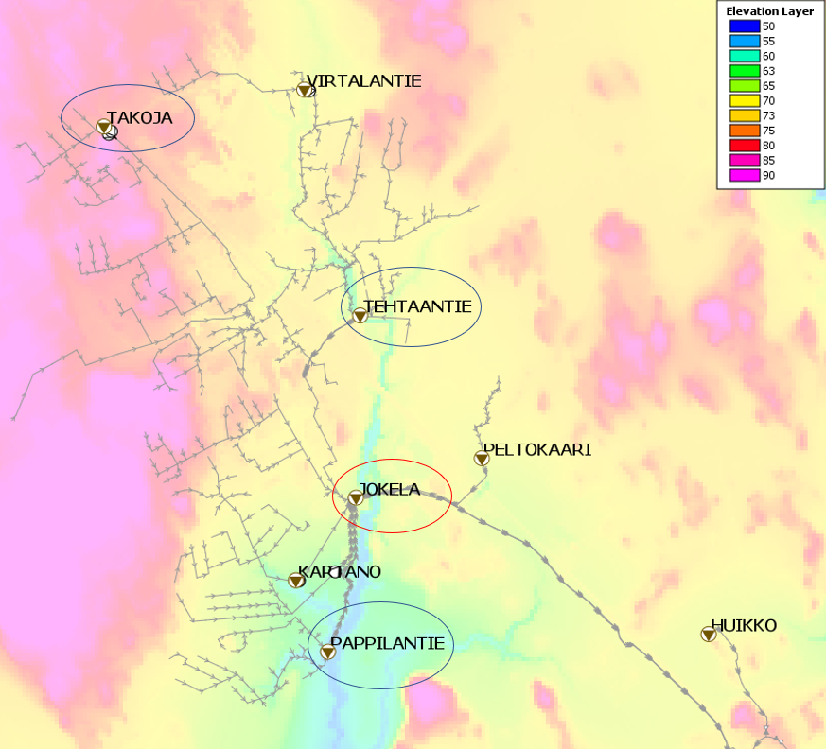

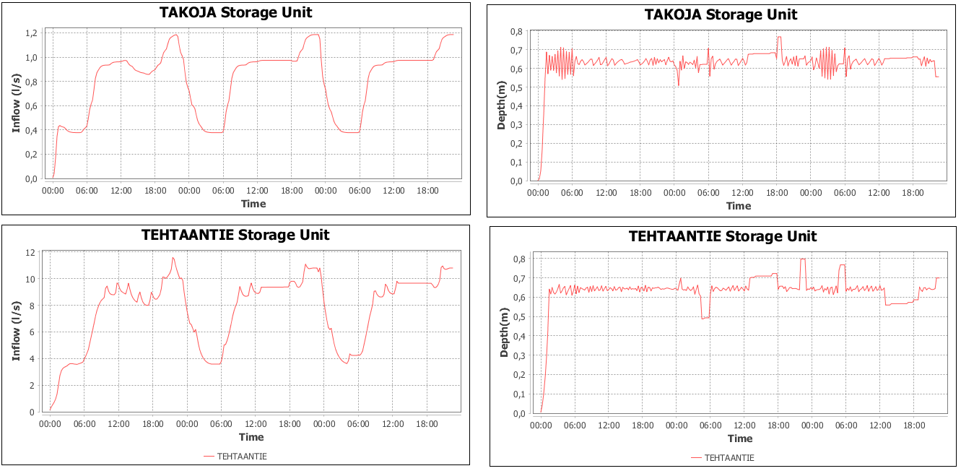

**Run RDII test scenario in Fluidit Storm/sewer to compare the above hydrographs and use as an explanation of which hydrographs we could expect from a wet weather period. If possible, use real rainfall /sewershed data. Maybe hide the name of the pumping stations.**

Distributions of rain gauges. (better image to be created in qgis: Inform name of the stations/location/time interval of observations/quantity of years/histogram of historical data for the areas)

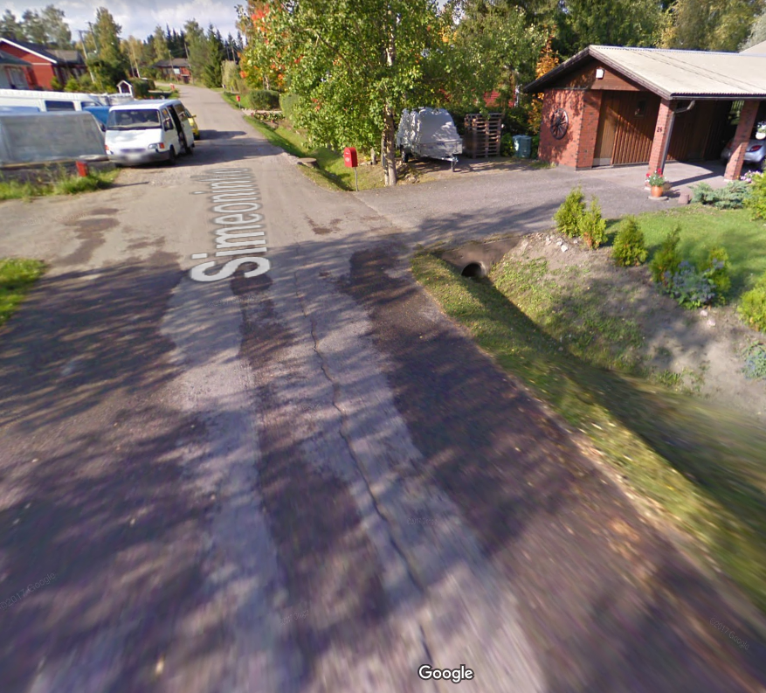

Google street view image> <https://www.google.com/maps/@60.5319857,24.9631051,3a,75y,341.38h,62.88t/data=!3m6!1e1!3m4!1sjfqnVvSEwwJOCoVg4ftTVg!2e0!7i13312!8i6656> > Simeonintie > stormwater ditch

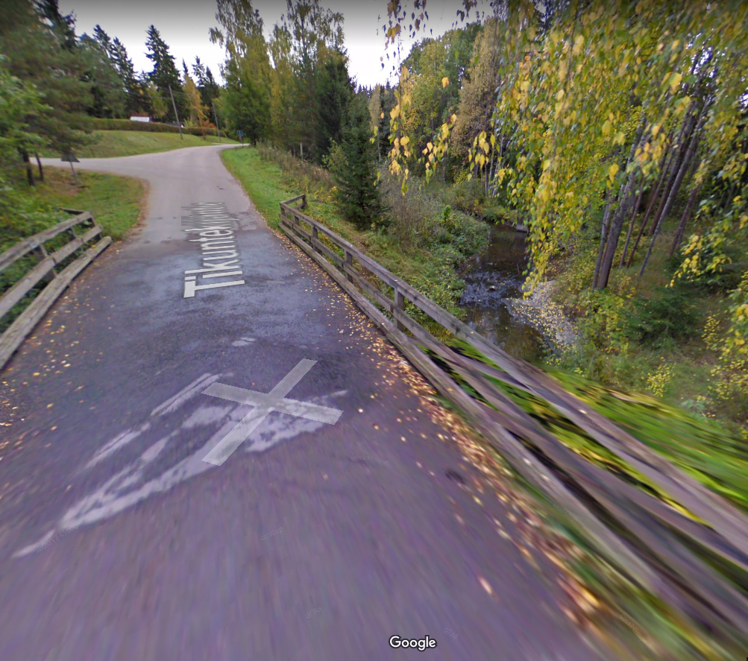

Bridge of tikuntekijäntie 1. Further check of the DEM in this location to evaluate whether the bridge was removed or not and if it would impact for the runoff i.e. when calculating the slope of the catchment

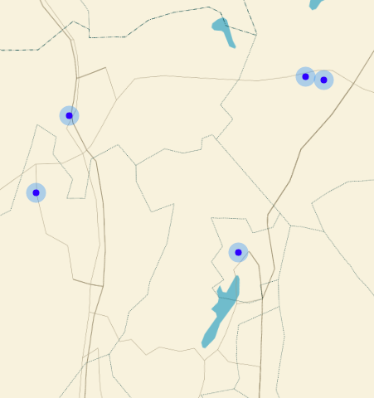

Hydraulic Model of Jokela

* 14 pumping stations

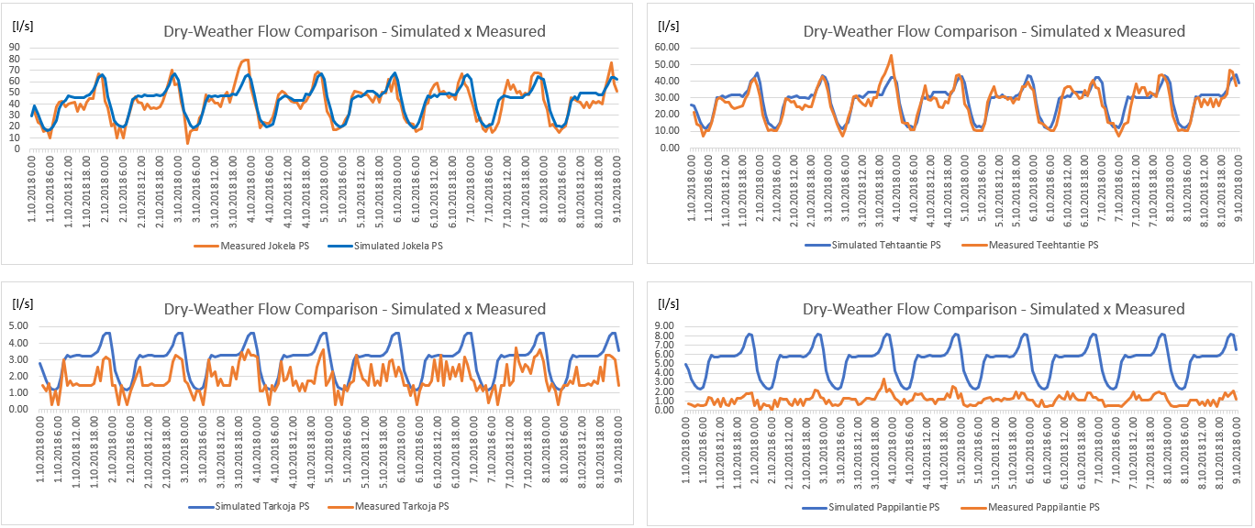

## Turku City

Wastewater Plant: <https://www.turunseudunpuhdistamo.fi/in-english>

Water Utility: <https://www.turunvesihuolto.fi/vesihuolto/tietoa-vedesta/mista-vesi-tulee>

<https://www.turunvesihuolto.fi/vesihuolto/tietoa-vedesta/vesihuollon-toiminta-alueet>

[https://www.turku.fi/sites/default/files/atoms/files//01_vesihuolto_toiminta-alue-ehdotus_jatevesi_nahtaville_fi-sv.pdf](https://www.turku.fi/sites/default/files/atoms/files/01_vesihuolto_toiminta-alue-ehdotus_jatevesi_nahtaville_fi-sv.pdf)

# Open Questions

The open questions will guide the next steps on the research carried for the development of the model. Some literature review able to support the answer of these questions is already suggested below each question.

**How different RDII quantification methods perform on a case study? Is there a case study done with similar catchment’s characteristics to Jokela or Turku?**

Include here results from case studies of the use of RDII methods: this can be found in [15] and [2], [14]

**Does climate change affect the forecast of CSO?**[20]**,**

**Does CSO affects drinking water source and infection risks?**[21]**,** [5]**,**

**How to choose rainfall and snowmelt events to calibrate and validate the model?**

**Would the sensitivity analysis result varies with different rainfall/snowmelt events? If yes, would that affect the choice of parameters to be optimized during automatic calibration?**

Rainfall:[22]**,** [23]

**Mention frost in the soil** [24]

# Bibliography

[1] S. Vallabhaneni and E. H. Burgess, “Computer Tools for Sanitary Sewer System Capacity Analysis and Computer Tools for Sanitary Sewer System,” *Environ. Prot.*, no. October, pp. 1–104, 2007.

[2] D. Bennett *et al.*, *Using flow prediction technologies to control sanitary sewer overflows*. 1999.

[3] C. Mosley, S. Dent, P. Kadota, L. T. Wright, and Y. Djebbar, “Comparing Rainfall Dependent Inflow and Infiltration Simulation Methods,” *J. Water Manag. Model.*, no. January, 2001.

[4] L. A. Rossman and W. C. Huber, “Storm Water Management Model Reference Manual. Volume I - Hydrology (Revised). EPA/600/R-15/162A,” vol. I, p. 231, 2016.

[5] A. M. de Roda Husman, T. de Nijs, A. Sterk, J. F. Schijven, and H. de Man, “Climate change impact on infection risks during bathing downstream of sewage emissions from CSOs or WWTPs,” *Water Res.*, vol. 105, pp. 11–21, 2016.

[6] L. A. Roesner, “Storm Water Management Model Manual,” *Usepa*, vol. I, no. July, 2009.

[7] M. Heikkinen, P. Schönach, and I. Massa, “Politicization of wastewater overflows: The case of the Vantaa River, Finland,” *Water Policy*, vol. 18, pp. 1454–1472, 2016.

[8] K. S. Choi and J. E. Ball, “Parameter estimation for urban runoff modelling,” *Urban Water*, 2002.

[9] B. A. Tolson and C. A. Shoemaker, “Dynamically dimensioned search algorithm for computationally efficient watershed model calibration,” *Water Resour. Res.*, 2007.

[10] S. Dent, R. B. Hanna, and L. T. Wright, “Automated Calibration using Optimization Techniques with SWMM RUNOFF,” *J. Water Manag. Model.*, pp. 220–238, 2004.

[11] R. Arsenault, A. Poulin, P. Côté, and F. Brissette, “Comparison of Stochastic Optimization Algorithms in Hydrological Model Calibration,” *J. Hydrol. Eng.*, 2013.

[12] M. Wallner, U. Haberlandt, and J. Dietrich, “Evaluation of different calibration strategies for large scale continuous hydrological modelling,” *Adv. Geosci.*, 2012.

[13] U. Epa, O. of Research, W. Supply, and W. Resources Division, “Review of Sewer Design Criteria and RDII Prediction Methods January 2008.”

[14] G. Barden, T. Fallara, H. Kelly, F. Cheng, B. J. Sherman, and E. Burgess, “Comparison of RDII Unit Hydrograph Approaches for Continuous Simulation using SWMM 5,” *J. Water Manag. Model.*, vol. 6062, pp. 209–222, 2015.

[15] D. Crawford, E. Pier, and P. L. Eckley, “Methods for Estimating Inflow and Infiltration into Sanitary Sewers,” *J. Water Manag. Model.*, vol. 6062, 2015.

[16] M. Chen, C. Tucker, S. Vallabhaneni, J. Koran, M. Gatterdam, and D. Wride, “Comparing Different Approaches Of Catchment Delineation,” *23nd Annu. Esri Int. User Conf.*, 2003.

[17] S. M. Shamead, C. Fan, W. Cao, D. Banting, and D. Joksimovic, “A New Automated Approach To Sewershed Delineation For Urban Drainage Modelling Studies: A City Of Toronto Case Study,” *11th Int. Conf. Hydroinformatics*, 2014.

[18] D. Wride, M. Chen, D. Ph, and R. Johnstone, “Characterizing the Spatial Variability of Rainfall Across a Large Metropolitan Area,” vol. 2, pp. 1–10, 2004.

[19] E. Turkheimer and M. Waldron, “Coordinated management of combined sewer overflows by means of environmental decision support systems,” *Sci. Total Environ.*, vol. 126, no. 1, p. 21, 2016.

[20] H. Tavakol-Davani, E. Goharian, C. H. Hansen, H. Tavakol-Davani, D. Apul, and S. J. Burian, “How does climate change affect combined sewer overflow in a system benefiting from rainwater harvesting systems?,” *Sustain. Cities Soc.*, vol. 27, pp. 430–438, 2016.

[21] I. Jalliffier-Verne *et al.*, “Impacts of global change on the concentrations and dilution of combined sewer overflows in a drinking water source,” *Sci. Total Environ.*, vol. 508, pp. 462–476, Mar. 2015.

[22] E. Turkheimer and M. Waldron, “Selection of rainfall information as input data for the design of combined sewer overflow solutions,” *Psychol. Bull.*, vol. 126, no. 1, p. 21, 2019.

[23] T. Müller, M. Schütze, and A. Bárdossy, “Temporal asymmetry in precipitation time series and its influence on flow simulations in combined sewer systems,” *Adv. Water Resour.*, vol. 107, pp. 56–64, Sep. 2017.

[24] A. Semadeni-Davies, “Urban snowmelt processes – current research and modelling needs,” Casco Bay Estuary Partnership (CBEP), Lund, 2003.

National Land Survey of Finland: <https://tiedostopalvelu.maanmittauslaitos.fi/tp/kartta?lang=en>

How to view gridded forecast data

GRIB2 and NetCDF format

Open source API and tools for decoding and encoding data in mesh formats

[https://confluence.ecmwf.int//display/ECC/ecCodes+Home](https://confluence.ecmwf.int/display/ECC/ecCodes+Home)

Example of time series from GR

<https://confluence.ecmwf.int/display/METV/Time+Series+from+GRIB+Example>

crayfish

<https://www.lutraconsulting.co.uk/blog/2018/10/18/mdal/>

<https://www.lutraconsulting.co.uk/products/crayfish/wiki/>

<https://www.lutraconsulting.co.uk/products/crayfish/>